**Introduction**

Since Big Mountain Resort has added a new chair lift, the operations costs have increased by $1,540,000. To mitigate these new costs and maintain a profit margin of 9.2 percent, new measures like increasing the price of adult weekend and weekdays tickets will need to be enacted. This project will build a model with the price of an adult weekend ticket as the output to determine an acceptable increase in price.

**Data Preprocessing**

The data set consists of information for 330 resorts in the United States that are part of the same market share as Big Mountain Resort. Missing values in the data set were handled either by entering the average for the given column into the missing values or by entering in the same value as another column. In addition, repetitive columns such as Summit Elevation and Drop Elevation were dropped from the data. Finally, the data was divided into three clusters using the kmeans clustering algorithm.

**Analysis**

A linear regression model was built to better understand the relationship between the input parameters and the output, the price of an adult weekend ticket and be able to predict the price for Big Mountain Resort. The regression model had an explained variance 0.935 and a mean absolute error of 5.13. Based on these metrics, the model does a decent job at explaining the changes in the ticket prices but does not accurately predict the ticket price. A mean absolute error of 5.13 means that a prediction on average is off by $5.13. The accuracy of the predictions is shown in Figure 1. If the model was perfectly accurate, all the points would land on the line.

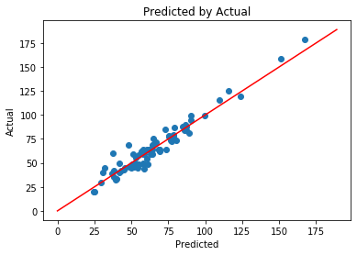

*Figure 1: This plot shows the predicted values using the linear regression model against the actual values.*

The coefficients of the linear regression model show was input parameters have the greatest effect on the output parameter. This information can be used to determine what additional changes could be made to the resort that would help justify an increase in ticket prices. Table 1 shows the top ten coefficients for the model. Based on these results, changing the number of triple or quad chair lifts would help increase ticket prices.

|  |  |
| --- | --- |
|  | **Coefficient** |
| **AdultWeekday** | 20.077032 |
| **clusters** | 2.639080 |
| **vertical_drop** | 2.030657 |
| **Runs** | 1.398990 |
| **triple** | 1.386426 |
| **surface** | 1.248313 |
| **quad** | 1.183345 |
| **daysOpenLastYear** | 1.156936 |
| **averageSnowfall** | 0.898052 |
| **fastQuads** | 0.705101 |

*Table 1: These are the absolute values of the coefficients of the linear regression model. A larger value means that input parameter has a great effect on the output parameter’s result.*

**Conclusion**

Though the model is not accurate enough to make predictions, it can still provide value in understanding the relationship between different features of a ski resort and their ticket prices. Based on this analysis, Big Mountain should be able to increase its ticket prices as a new chair lift increases the value of the resort. If a model capable of making predictions is necessary, then additional data or a new model will be required.